**REPORT ON**

*An assignment submitted in partial fulfillment of the requirements for the 1st internal assessment for the degree of*

**MASTER OF COMPUTER APPLICATIONS**

**GOUTHAM V N**

**1AT23MC033**



**Department Of Master of Computer Applications**

**ATRIA INSTITUTE OF TECHNOLOGY**

(An Autonomous Institution, Bengaluru)

Anandnagar, Bengaluru - 560 024

Approved by AICTE, Affiliated to VTU, Belagavi

Accredited by NAAC A++ & NBA

2024 - 2025

**QUESTION?**

* Develop a small website with multiple pages that demonstrates the use o all the above concepts.
* The website should include

1. HOME PAGE (Basic syntax and structure, Text markup, images)
2. ABOUT PAGE (Lists, Tables, Media tag)
3. CONTACT PAGE (Form, Frame)

**XHTML (Extensible Hypertext Markup Language)**

It is a cross between a programming language HTML & XML

XHTML is the next generation of HTML

XHTML is aimed to replace HTML

HTML is Hyper Text Markup Language. It is the standard markup language for creating web pages

**TAGS USED:**

* <html> ...... </html>: The root element
* <head>……</head>: Define the head section of an HTML document
* <title>……. </title>: It gives a web page title
* <body>……</body>: Define the main content of a web page, including text, images, links and other HTML elements
* <nav>…. </nav>: Defines a section of a page that links to other pages or to parts within the page
* <ul>…. </ul>: Defines an unordered list
* <li>…. </li>: Used to represent an item in a list
* <h1>…</h1>: Defines the most important heading
* <p>…. </p>: Defines a paragraph
* <img>: Used to incorporate in-line graphics into an HTML documents
* <form>…. </form>: Used to collect data from the user and send it to the server for further processing
* <label>…. </label>: Used to associate a text label with a form <input> field
* <br>: Create a break in the line of text
* <textarea>…. </textarea>: Defines a multi-line text input control
* <audio>…</audio>: Used to embed sound content in a document, such as music or other audio streams
* <video>…. </video>: Used to embed video content in a document, such as a movie clip or other video streams

**HOME PAGE:**

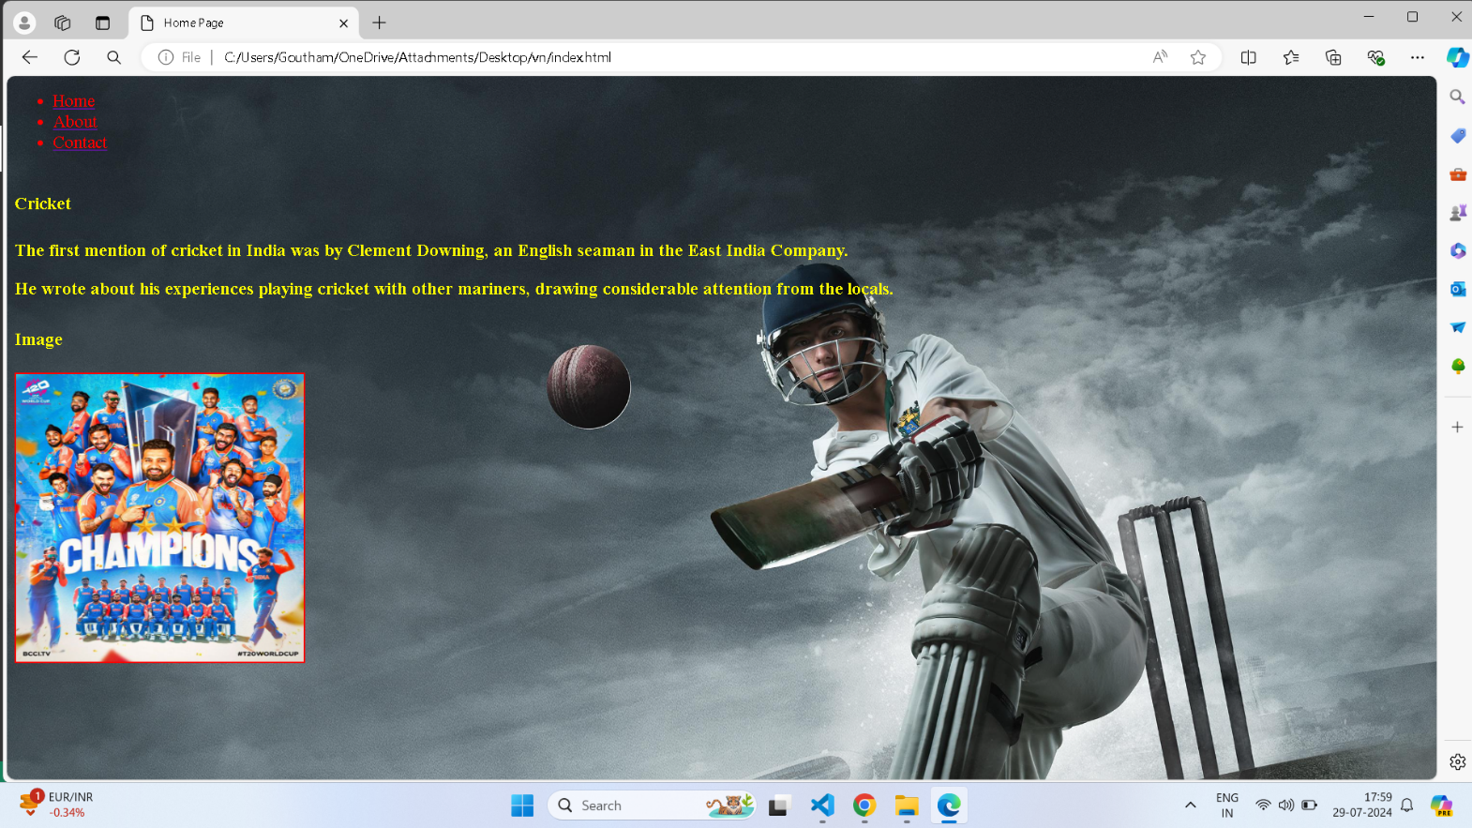

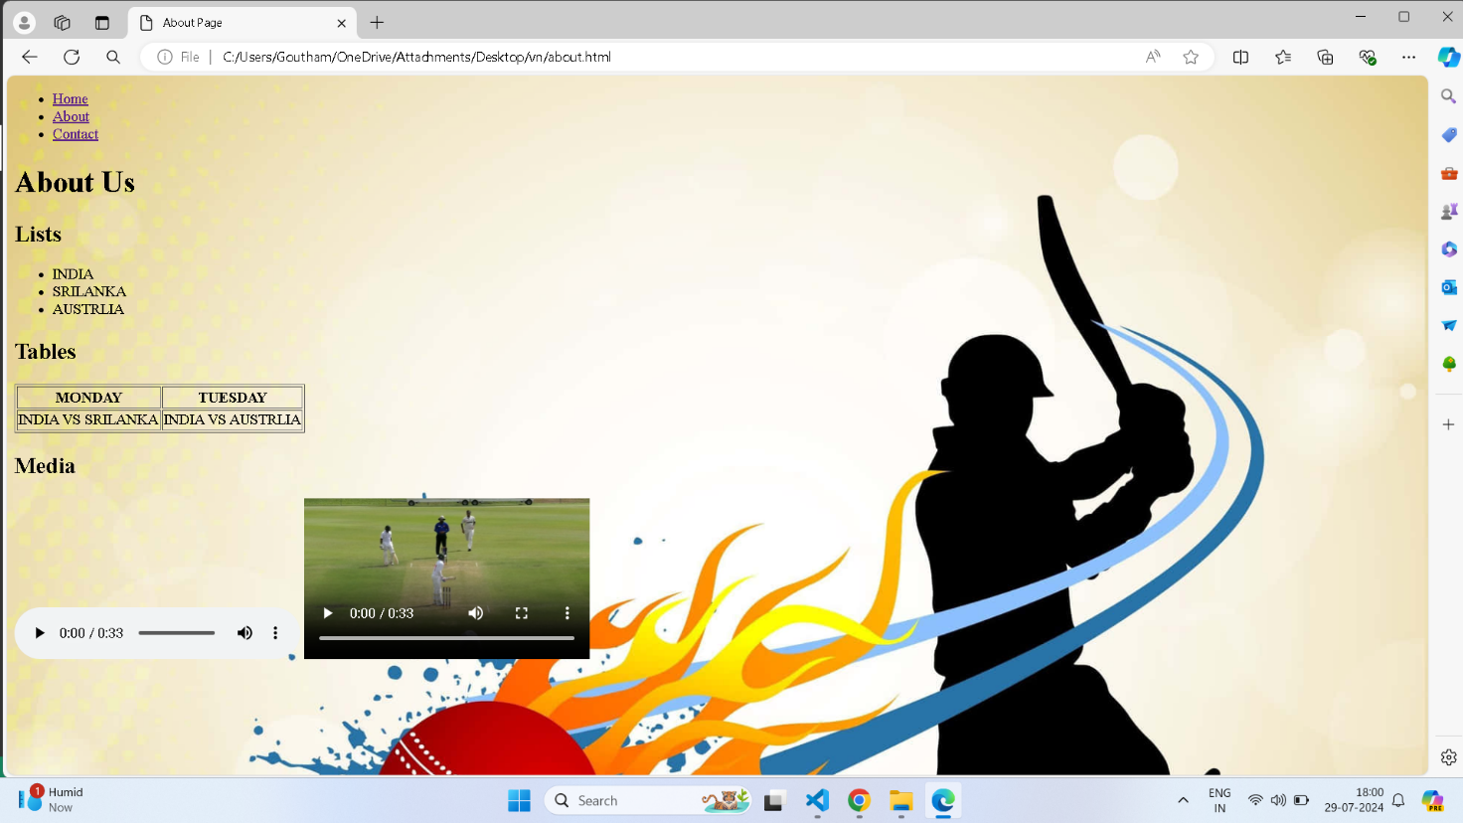**ABOUT PAGE:**

**CONTACT PAGE:**

